5.102: (a) The retarding force of the surface is the only horizontal force acting. Thus
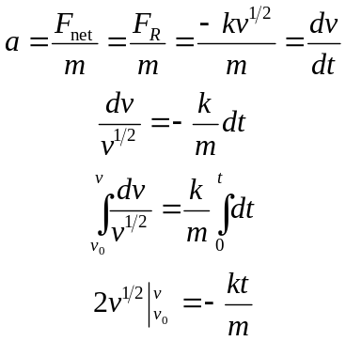
which gives
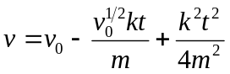
For the rock’s position:
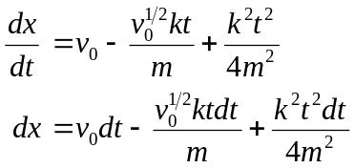
and integrating gives
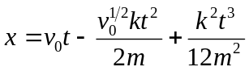
(b)
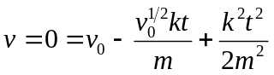
This is a quadratic equation in t; from the quadratic formula we can find the single solution:
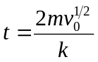
(c) Substituting the expression for t into the equation for x:
